Table A The frame of the proposal

2. The Cesaro sum technique

3. The Stokes’ transformation

Numerical methods approach

The one-dimensional wave equation

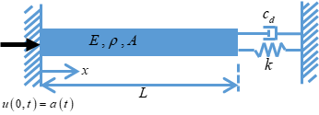

Earthquake engineering (support motion)

1. Mode superposition method +

the quasi-static decomposition method

2. The method of characteristic+

diamond rule

The second-order PDE (bar)

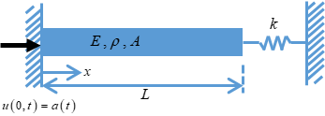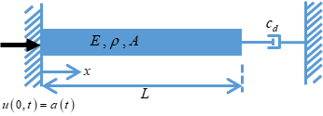

Analytical approaches

1. Finite element method (FEM)

2. The large mass FEM simulation technique

3. The large stiffness FEM simulation technique

The fourth-order PDE (beam)

Analytical approaches

(Series solution)

1. Mode superposition method + the quasi-static decomposition method

Numerical methods approach

Preliminary results of NTOU/MSV, Taiwan

**proposed researches**

**preliminary results**

Fig. 1 The frame of this proposal



JOM, 2022, Vol.38, pp.473-490

Priori treatment

Posteriori treatments

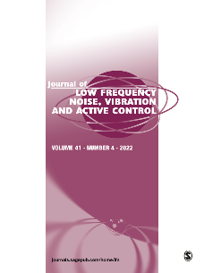

JLFNVAC, 2022, Vol.41, No.3, pp.1014-1029

(Memorial paper for Prof. C. S. Yeh)

Focus of this project

1. Finite element method (FEM)

2. The large mass FEM simulation technique

3. The large stiffness FEM simulation technique

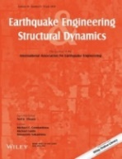

EESD, 1996, Vol.25(9), pp.909-925

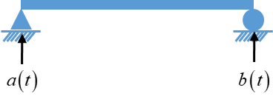

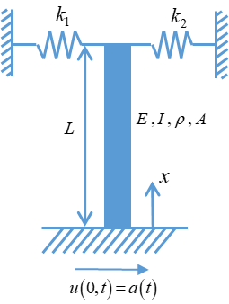

Preliminary results of NTOU/MSV, Taiwan

(Joint work with Prof. C. S. Yeh)