國立臺灣海洋大學河海工程學系2020偏微分方程 Method of complete integral

Solve the PDE by using the method of complete integral

G.E. : 

Cauchy Data : 

Two parameter family:

Assume:

|  |  |
| --- | --- |
|  | (1) |

將Cauchy Data代入 (1)得

|  |  |
| --- | --- |
|  | (2) |

將(2)對微分得

|  |  |
| --- | --- |
|  | (3) |
|  | (4) |

代入(4)到(2)得

|  |  |
| --- | --- |
|  | (5) |

當,代入(4)

|  |  |
| --- | --- |
|  | (6) |

將(6)代入(1)得

|  |  |
| --- | --- |
|  | (7) |

當,代入(4)

|  |  |
| --- | --- |
|  | (8) |

將(8)代入(1)得

|  |  |
| --- | --- |
|  | (9) |

將(9)對微分得

|  |  |
| --- | --- |
|  | (10) |

將(9)與(10)平方相加得

|  |  |
| --- | --- |
| , 取正不合 | (11) |

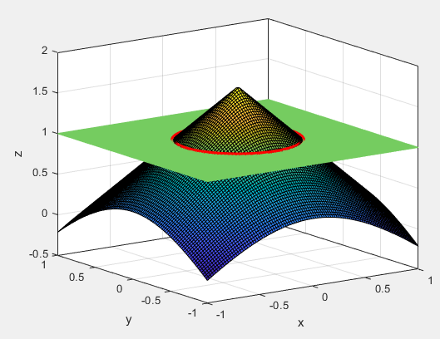

解一

解二