**Beprog144無限域退化尺度MFS(幾何、佈點，同心不同焦)**

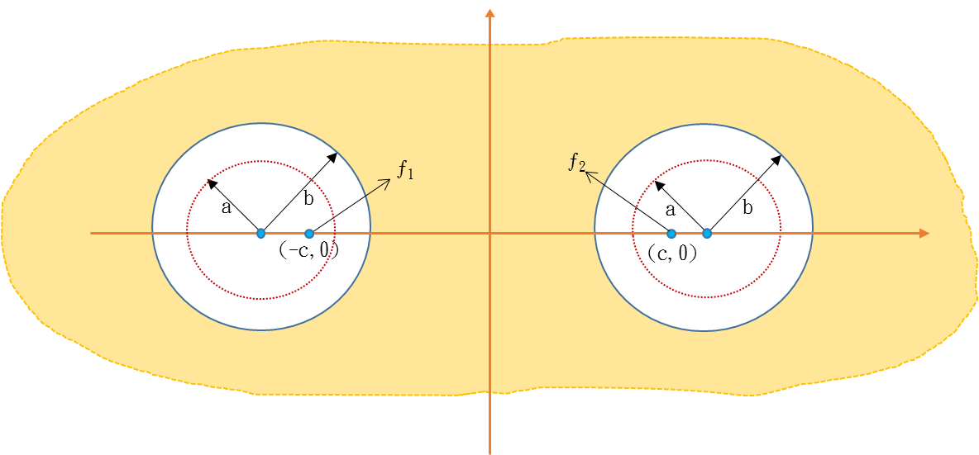



 

其中， a為0.485571，b為0.55056，c為0.8，ƒ1=(-c,0) ，ƒ2=(c,0) ，

=(-0.971142，0)、=(0.971142，0)

例題1. BC：，

正解：

例題2. BC：，

正解：

例題3. 正解

**References**

1. J. T. Chen, H. C. Shieh, J. J. Tsai and J. W. Lee, A study on the method of fundamental solutions using an image concept. Applied Mathematical Modelling, Vol. 34, pp. 4253-4266, 2010.
2. J. T. Chen, J. L. Yang, Y. T.　Lee and Y. L. Chang, Formulation of the MFS for the two-dimensional Laplace equation with an added constant and constraint, Engineering Analysis with Boundary Elements, Vol. 46, pp. 96–107, 2014
3. J. T. Chen, S. K. Kao and J. W. Lee, Analytical derivation and numerical experiment of degenerate scale by using the degenerate kernel of the bipolar coordinates.