**Beprog 147勢能理論的對數容量與邊界元素法的退化尺度之連結-雙切圓盤為例**  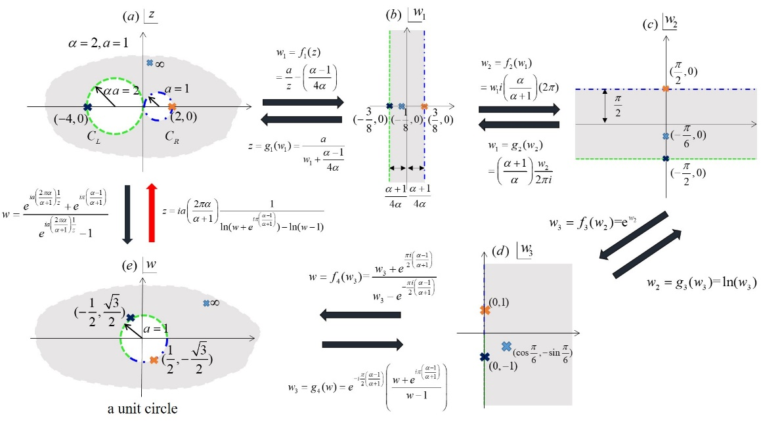

圖一

退化尺度可以透過2個指標來找出，第一個是奇異值，第二個是對數容量(logarithmic capacity)。將單位圓透過Riemann conformal mapping映射到任意外形，可得，此時對數容量即為黎曼保角映射中線性項的領導係數，當，這時所對應的尺寸即稱為退化尺度[1]。此研究透過一連串的mapping如圖一，可得單位圓mapping至雙切圓盤問題之Riemann conformal mapping 

可由3種方法來求得

1:  2: 3. [6]，此研究適用法1與法2，法3則較適用於多邊形。

當，即可得雙切圓盤退化尺度解析公式：

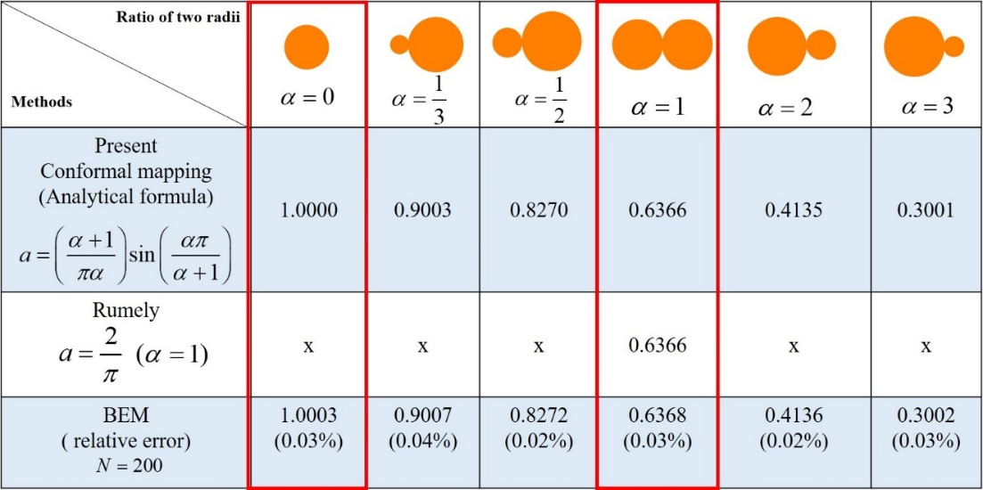

表一

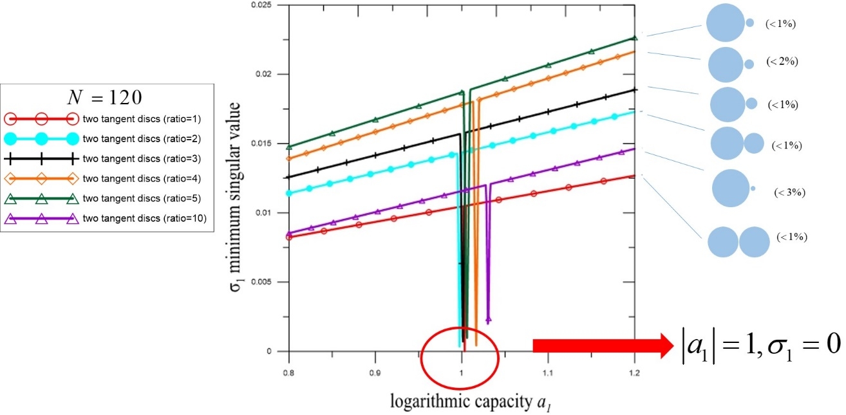

圖二

表一顯示[5-6]是我們的特例之一，且與BEM結果吻合。圖二則連結退化尺度的2個指標。此外，本研究與[7]所提的mapping函數相比，更具彈性。詳細求解過程與比較可見Note 2。

**References**

1. S.R. Kuo, J.T. Chen, S.K. Kao, Linkage between the unit logarithmic capacity in the theory of complex variables and the degenerate scale in the BEM/BIEMs, Appl. Math. Lett., 26(9) (2013) 929-938.
2. S.R. Kuo, J.T. Chen, J.W. Lee and Y.W. Chen, Analytical derivation and numerical experiments of degenerate scale for regular N-gon domains in BEM. Appl. Math. Comput. 219:5668-5683 (2013).
3. J.T. Chen, S.R. Kuo, S.K. Kao and J. Jian, 2015, Revisit of a degenerate scale: a semi-circular disk. J. Comput. Appl. Math. 283:182-200 (2015).
4. M. Kimura, Asymptotic estimation for the condition numbers in BEM. Numer. Math. 73:209-233 (1996).
5. R.S. Rumely. Capacity Theory on Algebraic Curves. Lecture Notes in Mathematics 1378. Berlin (BER): Springer-Verlag, 1989.
6. I.G. Petrovsky, Lectures on Partial Differential Equations, Interscience, 1954.
7. V.I. Ivanov and M.K. Trubetskov, Handbook of conformal mapping with computer aided visualization., CRC press, 1995.

**Note**

1.黃乙玲獲第43屆力學會議競賽固力組-第二名(2019)

2. J.T. Chen. S.R. Kuo, Y.L Huang and S.K Kao, 2019, Linkage of logarithmic capacity in potential theory and degenerate scale in the BEM for the two tangent discs, Applied Mathematics Letters, 102 (2020), 106135.