Projection:

**Least squares & Projection & Reproducing kernel & precondition**

Given  project  to have

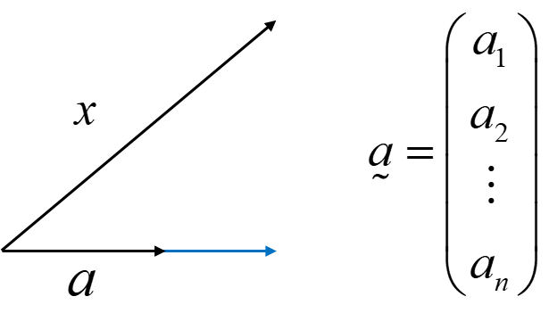

Least squares:



